♀22. Justice (Cell Division)—Track 26 
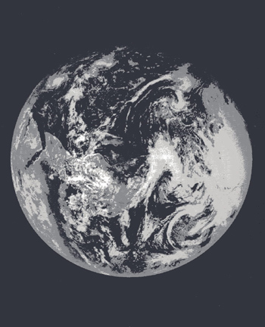
There YOU are—the whole planet as an organism.

Perhaps nothing known to modern science is as unlikely and outrageous as the daily work of our genes. From food, water, and air, they make a human being. Genes make proteins. Proteins are us. And from this audacious process come humans, who are themselves audacious. Not content simply to sit back and marvel at this infinitesimal artistry, people seek to control and improve it.


